Rat Cage Lid Modification Procedure

Parts List:

|  |  |  |  |
| --- | --- | --- | --- |
| Name | Part Number | Vendor / Part Type | Qty / Unit |
| Rat Cage Lid |  | Purchased-Techniplast | 1 |
| RC Panel Front | J009859 | Custom machined | 1 |
| RC Panel Front for Bottle | J009837 | Custom machined | 1 |
| RC Panel Side | J009838 | Custom machined | 2 |
| RCBH4 Weldment | J008644 | Custom weldment-GoProto | 1 |
| RC Bracket Front | J009600 | Custom sheetmetal-GoProto | 2 |
| RC Bracket Long | J009835 | Custom sheetmetal-GoProto | 2 |
| RC Bracket Side | J009836 | Custom sheetmetal-GoProto | 2 |
| Card Holder Bracket | J010308 | Custom sheetmetal-GoProto | 1 |
| Rat Cage Flap Assembly |  | Purchased-Part of Techniplast Lid | 1 |
| Rivets - .063” - .125” | 97447A015 | McMaster | 28 |
| Rivets - .126” - .187” | 97447A020 | McMaster | 22 |
| Rivets - .188” - .25” | 97447A025 | McMaster | 2 |
| 18-8 SS No. 4 Washer | 98019A309 | McMaster | 8 |
| 18-8 SS No. 5 Washer | 90945A712 | McMaster | 20 |
| Epoxy, 3M DP125 | 7467A65 | McMaster | 1 |

Tools List:

|  |  |  |  |
| --- | --- | --- | --- |
| Name | Part Number | Vendor | Quantity/Unit |
| Angle Grinder/Dremel |  |  |  |
| 1/8” Drill Bit |  |  |  |
| #28 Drill Bit |  |  |  |
| Power Drill |  |  |  |
| Pliers |  |  |  |
| Epoxy Applicator Gun | 74695A71 | McMaster | 1 |
| Masking Tape |  |  | 1 |
| Binder Clips (optional) |  |  | 2 |

Procedure

1. Cut Cage Lid
   1. Cut water bottle holder sections off the lid – cut lines shown in red on right picture

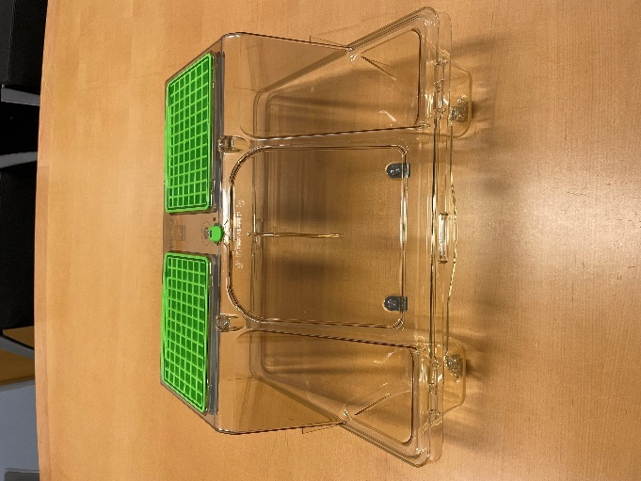 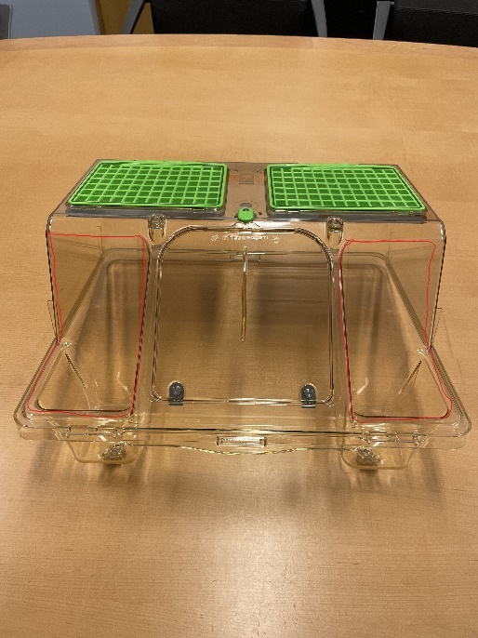

* 1. Save metal flap assembly for reattachment to modified cage – there should be four components
     1. Axle, spring, axle-mounted flap, large rectangular cover

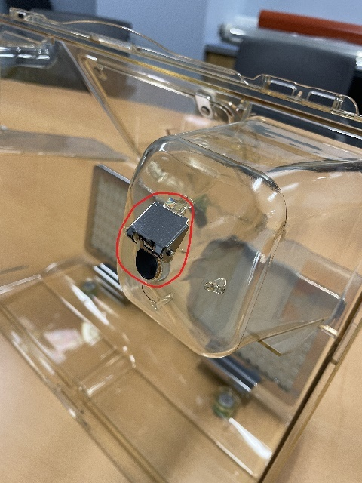

* 1. Grind off both card holders on the front

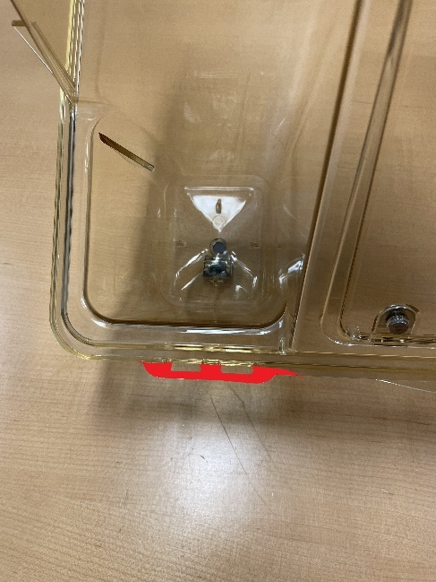

1. Assemble Flat Cover

Parts:

|  |  |
| --- | --- |
| Part Number | Quantity |
| J009859 | 1 |
| J009838 | 1 |
| J009600 | 1 |
| J009835 | 1 |
| J009836 | 1 |
| 97447A015 | 10 |
| 90945A712 | 2 |

* 1. Rivet front panel (J009859) and side panel (J009838) together using the long bracket (J009835) and six 97447A015 rivets
     1. Proper orientation of the panels, with respect to each other:

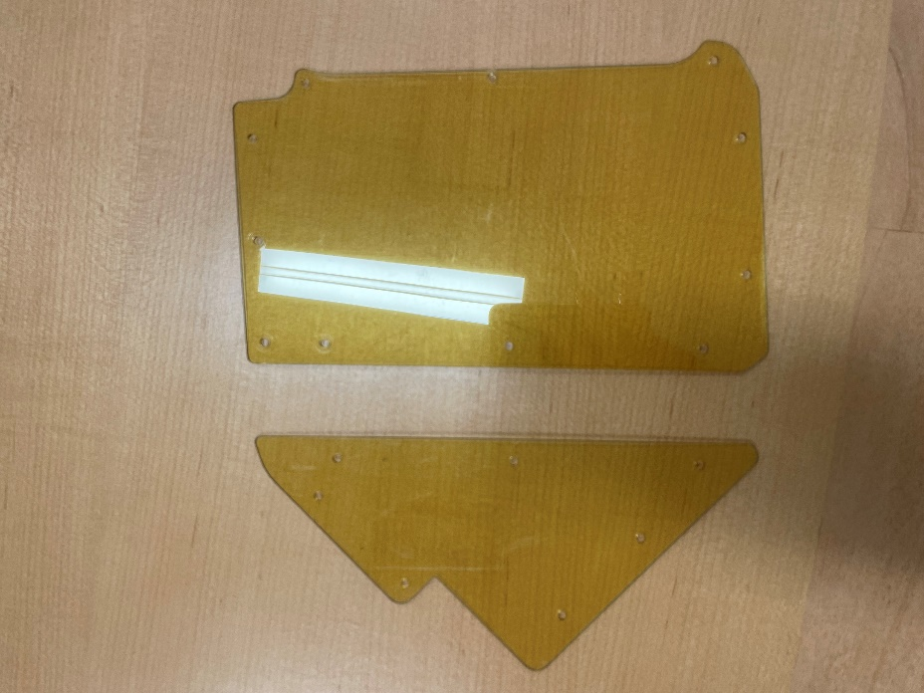

* + 1. The bracket is not symmetrical – the side with square corners should be attached to the front panel
    2. Bracket should be attached on the inside of the panels, with rivets attached from the outside, so the flat head is on the outside of the plastic

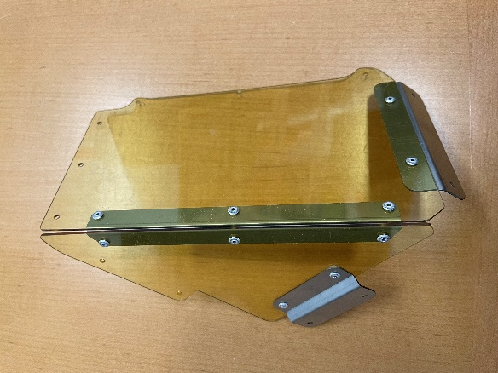 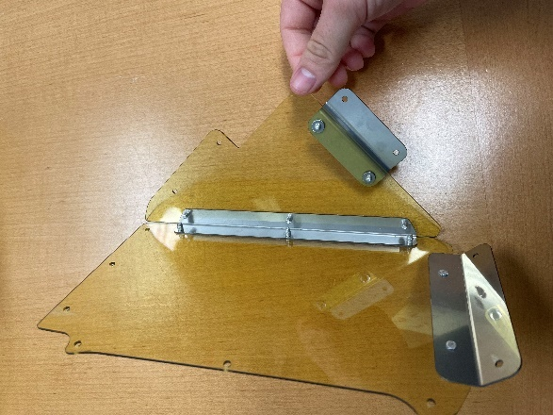

* 1. Rivet front bracket (J009600) to the front panel with two 97447A015 rivets
     1. Bracket should be on the inside of the panel, with the bracket extending down below the panel
     2. Rivets attached from the outside, so the flat head is on the outside of the plastic

* 1. Rivet side bracket (J009836) to the side panel with two 97447A015 rivets
     1. Bracket should be on the outside of the panel, with the short side of the “z” attached to the panel and the bracket jutting out away from the panel
     2. Rivets will be attached through the bracket into the panel – use two washers (90945A712) behind the panel

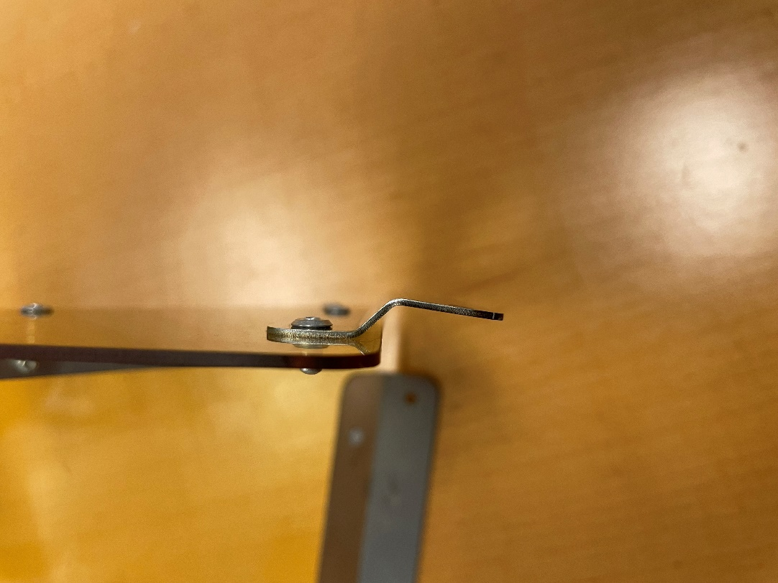

1. Assemble Water Bottle Holder Cover

Parts:

|  |  |
| --- | --- |
| Part Number | Quantity |
| J009837 | 1 |
| J009838 | 1 |
| J008644 | 1 |
| J009600 | 1 |
| J009835 | 1 |
| J009836 | 1 |
| 97447A015 | 18 |
| 90945A712 | 2 |
| 98019A309 | 8 |
| Cage Flap Assembly Parts | 1 ea. axle, spring, flap, cover |

* 1. Attach RCBH4 Weldment (J008644) to the front panel (J009837) in the orientation shown here using eight 97447A015 rivets

* 1. Rivet front panel and side panel (J009838) together using the long bracket (J009835) and six 97447A015 rivets
     1. Proper orientation of the panels, with respect to each other:

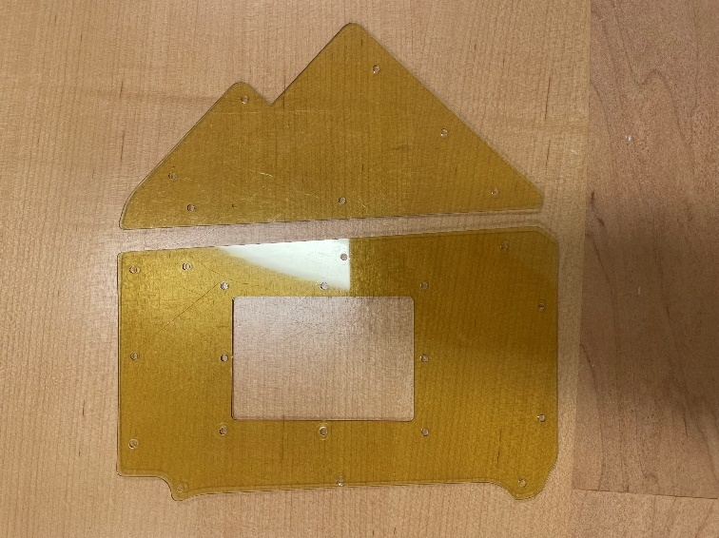

* + 1. The bracket is not symmetrical – the side with square corners should be attached to the front panel
    2. Bracket should be attached on the inside of the panels, with rivets attached from the outside, so the flat head is on the outside of the plastic

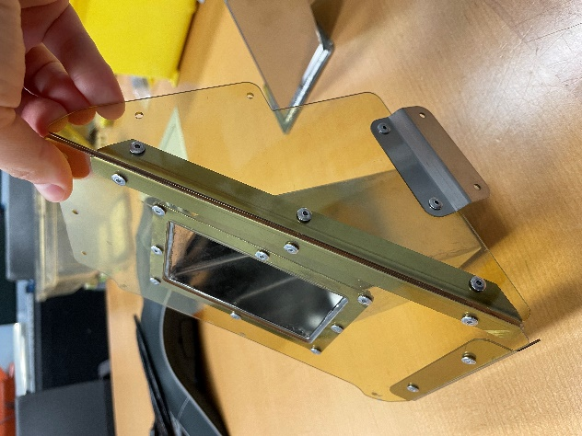

* 1. Rivet front bracket (J009600) to the front panel with two 97447A015 rivets
     1. Bracket should be on the inside of the panel, with the bracket extending down below the panel
     2. Rivets attached from the outside, so the flat head is on the outside of the plastic

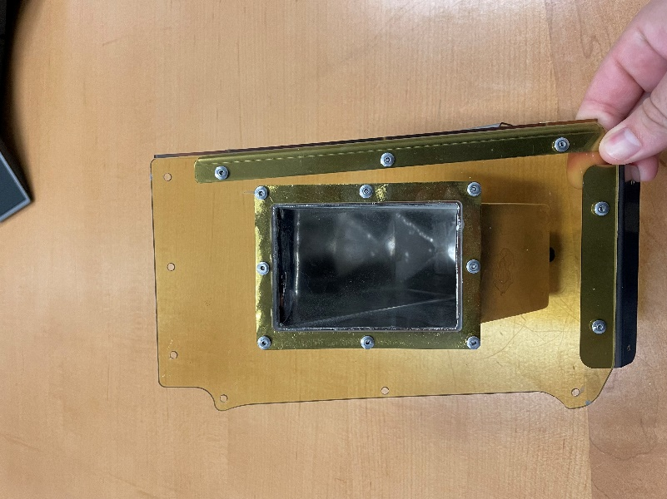 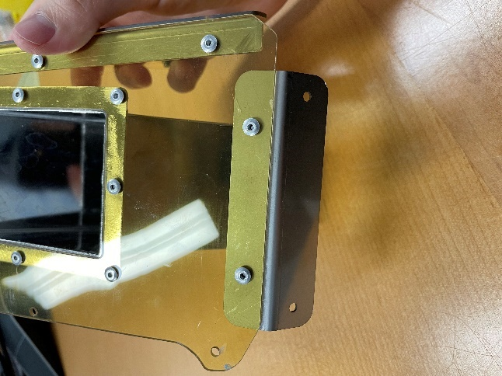

* 1. Rivet side bracket (J009836) to the side panel with two 97447A015 rivets
     1. Bracket should be on the outside of the panel, with the short side of the “z” attached to the panel and the bracket jutting out away from the panel
     2. Rivets will be attached through the bracket into the panel – use two washers (90945A712) behind the panel

* 1. Attach cover flap assembly to weldment
     1. Axle spans the two tabs on the weldment, below the through hole for the water bottle tip
     2. Eight 98019A309 washers should sandwich the flap and spring, four on either side, to keep the flap and spring centered over the through hole

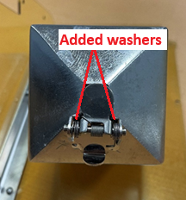

* + 1. Cover should snap into grooves in the axle and click into place

* + 1. Bend tab over far enough to ensure cover will stay in place.

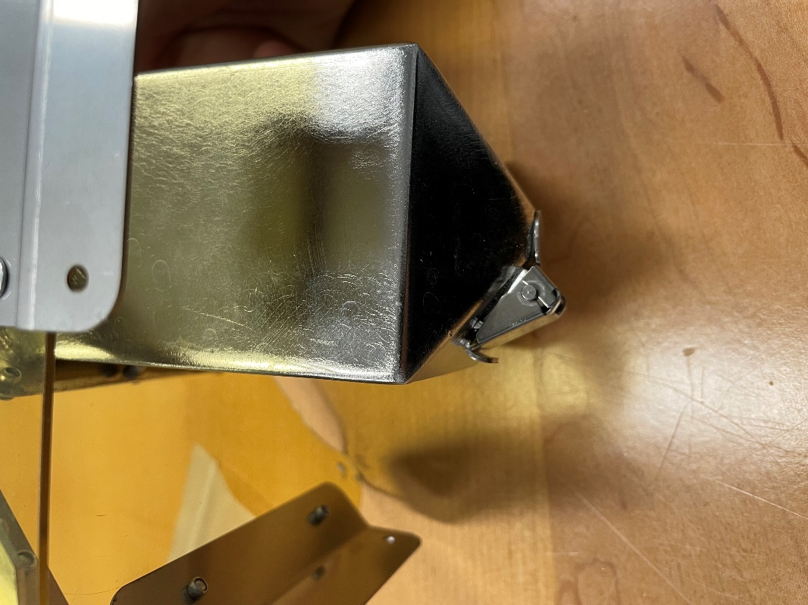

1. Attach Water Bottle Cover Assembly to Cage

Parts:

|  |  |
| --- | --- |
| Part Number | Quantity |
| 97447A020 | 12 |
| 90945A712 | 8 |

* 1. Use cover assembly as guides to drill mounting holes through cage lid – hole locations marked in red
     1. Water bottle holder assembly mounts on right side of lid when looking at the front
     2. Drill initial holes with 1/8” bit

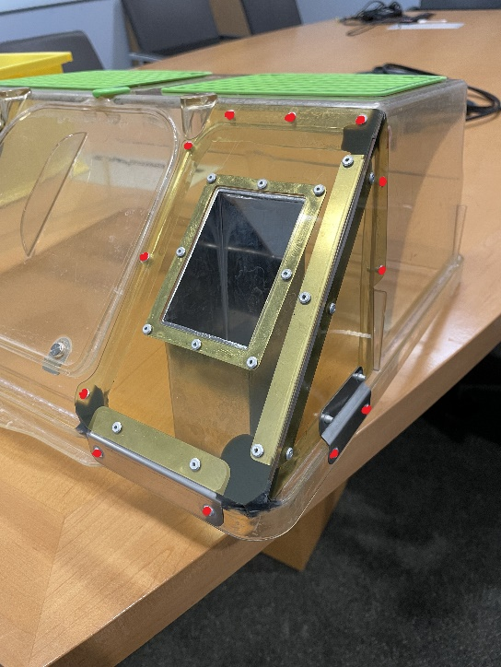

* + 1. Can be helpful to hold the cover assembly in place with binder clips while drilling

* 1. Remove cover assembly and enlarge holes with #28 drill bit
  2. Attach cover assembly to lid using twelve 97447A020 rivets
     1. The eight rivets going through the front and side walls of the cage lid, as opposed to the bottom rim, should have backing washers (90945A712) behind the lid – locations shown in red. The rivets going through the bottom rim should be installed from the inside.

* + 1. The washer for the hole circled in blue will need to be cut into a D-ring to fit in the compressed space along the thin wall

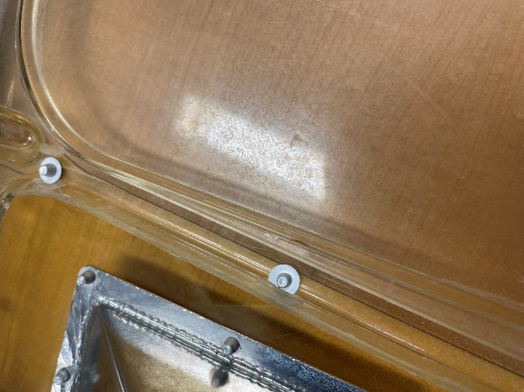

* + 1. The two rivets through the bottom lip on the right side of the lid need to be installed from the inside.

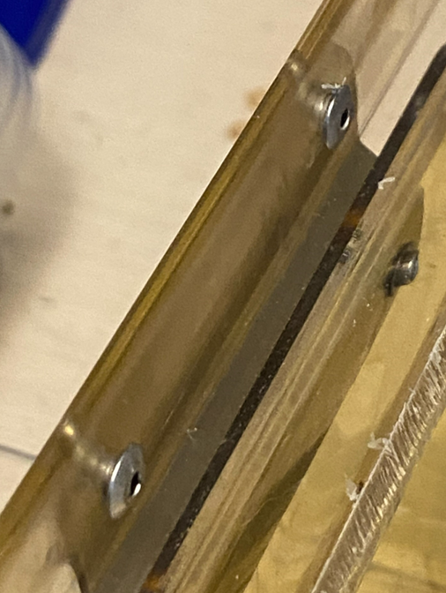

1. Attach Flat Cover Assembly to Cage

Parts:

|  |  |
| --- | --- |
| Part Number | Quantity |
| 97447A020 | 10 |
| 90945A712 | 8 |
| J010308 | 1 |
| 97447A025 | 2 |

* 1. Use cover assembly as guides to drill mounting holes through cage lid – hole locations marked in red
     1. Flat panel assembly mounts on left side of lid when looking at the front
     2. Drill initial holes with 1/8” drill bit

* + 1. Can be helpful to hold the cover assembly in place with binder clips while drilling
  1. Remove cover assembly and enlarge holes with #28 drill bit if needed to install rivets.
  2. Attach cover assembly to lid
     1. The eight rivets going through the front and side walls, as opposed to the bottom rim, should have backing washers behind the lid plastic – locations shown in red. The rivets going through the bottom rim should be installed from the inside.

* + 1. The washer for the hole circled in blue will need to be cut into a D-ring to fit in the compressed space along the thin wall

* + 1. The card holder bracket (J010308) should be riveted to the front lip of the lid along with the cover using two 97447A025 rivets

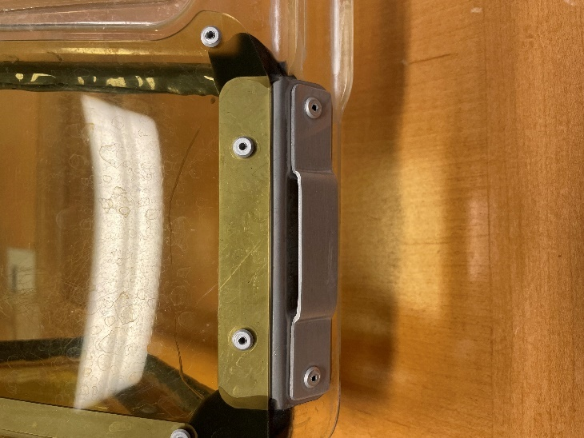

* + 1. At all ten other points of attachment, the 97447A020 rivets are sufficient
    2. The two rivets through the bottom lip on the left side of the lid need to be installed from the inside.

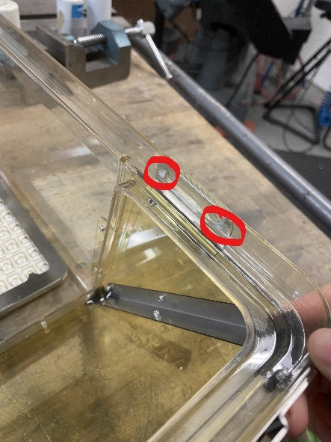 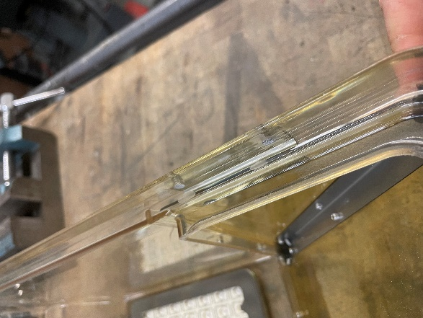

1. Epoxy
   1. Seal the corners of the covers with epoxy (7467A65)
      1. Circled corners need epoxy

Note: There is epoxy all the way around the cut opening in the left side of the lid in these photos – that is leftover from a different modification. Do not replicate this

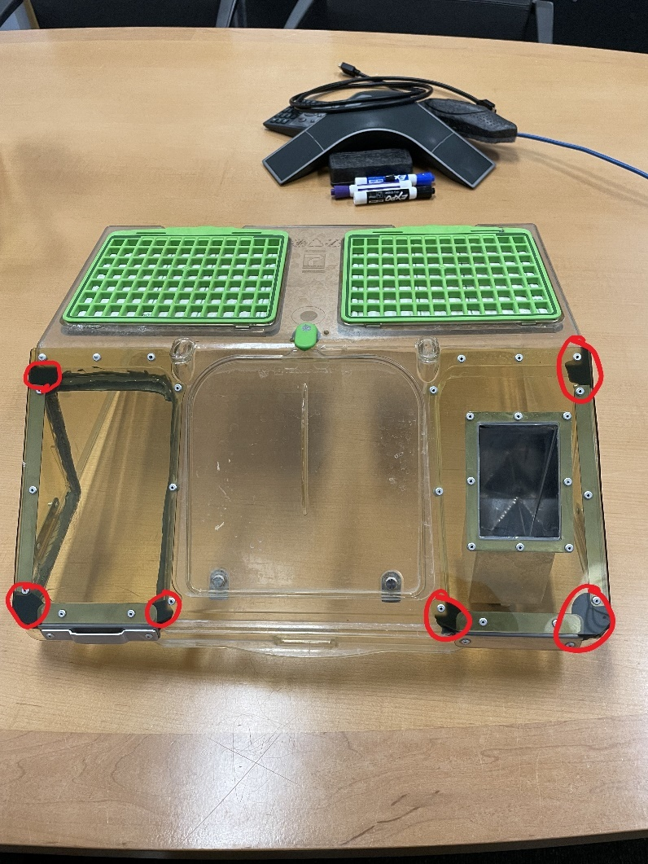

* + 1. Tape over the openings

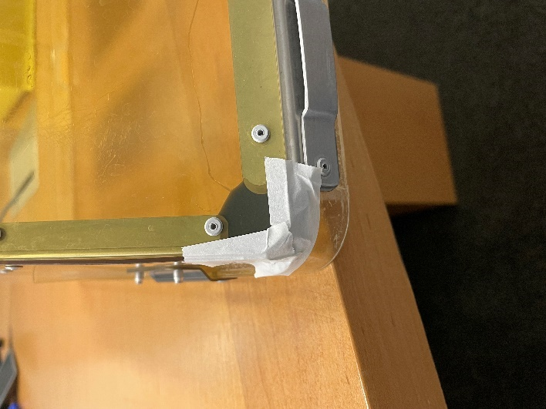 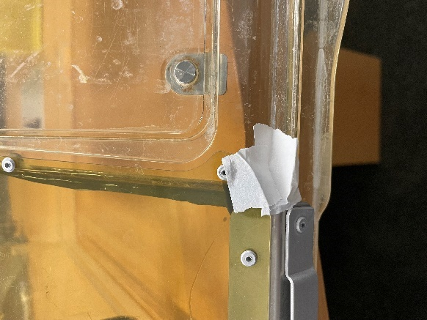

* + 1. Inject epoxy with applicator gun from the inside of the lid

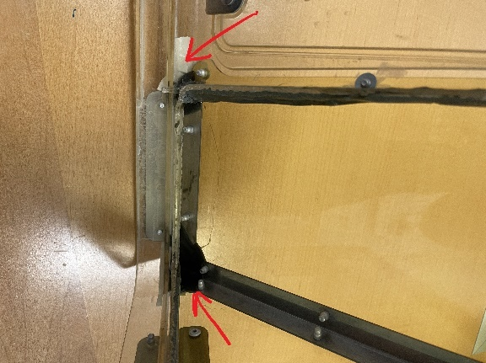

* + 1. Stand on end to prevent epoxy from running and let dry 24 hours before removing tape
    2. After epoxy has dried remove tape and examine the outer surfaces of the cage for sharp edges created by sagging epoxy. **Sand any sharp edges that could cut skin or tear gloves.**

|  |  |  |
| --- | --- | --- |
| Revision History | | |
| DATE | INITIALS | DESCRIPTION |
| 8/4/2025 | JBA | Added note about sanding sharp edges and pointed out flap spacer washers |
| 9/23/2025 | JBA | Add better images and descriptions re: washers and rivet install direction on lower lid flange, to be installed from inside. |